1.

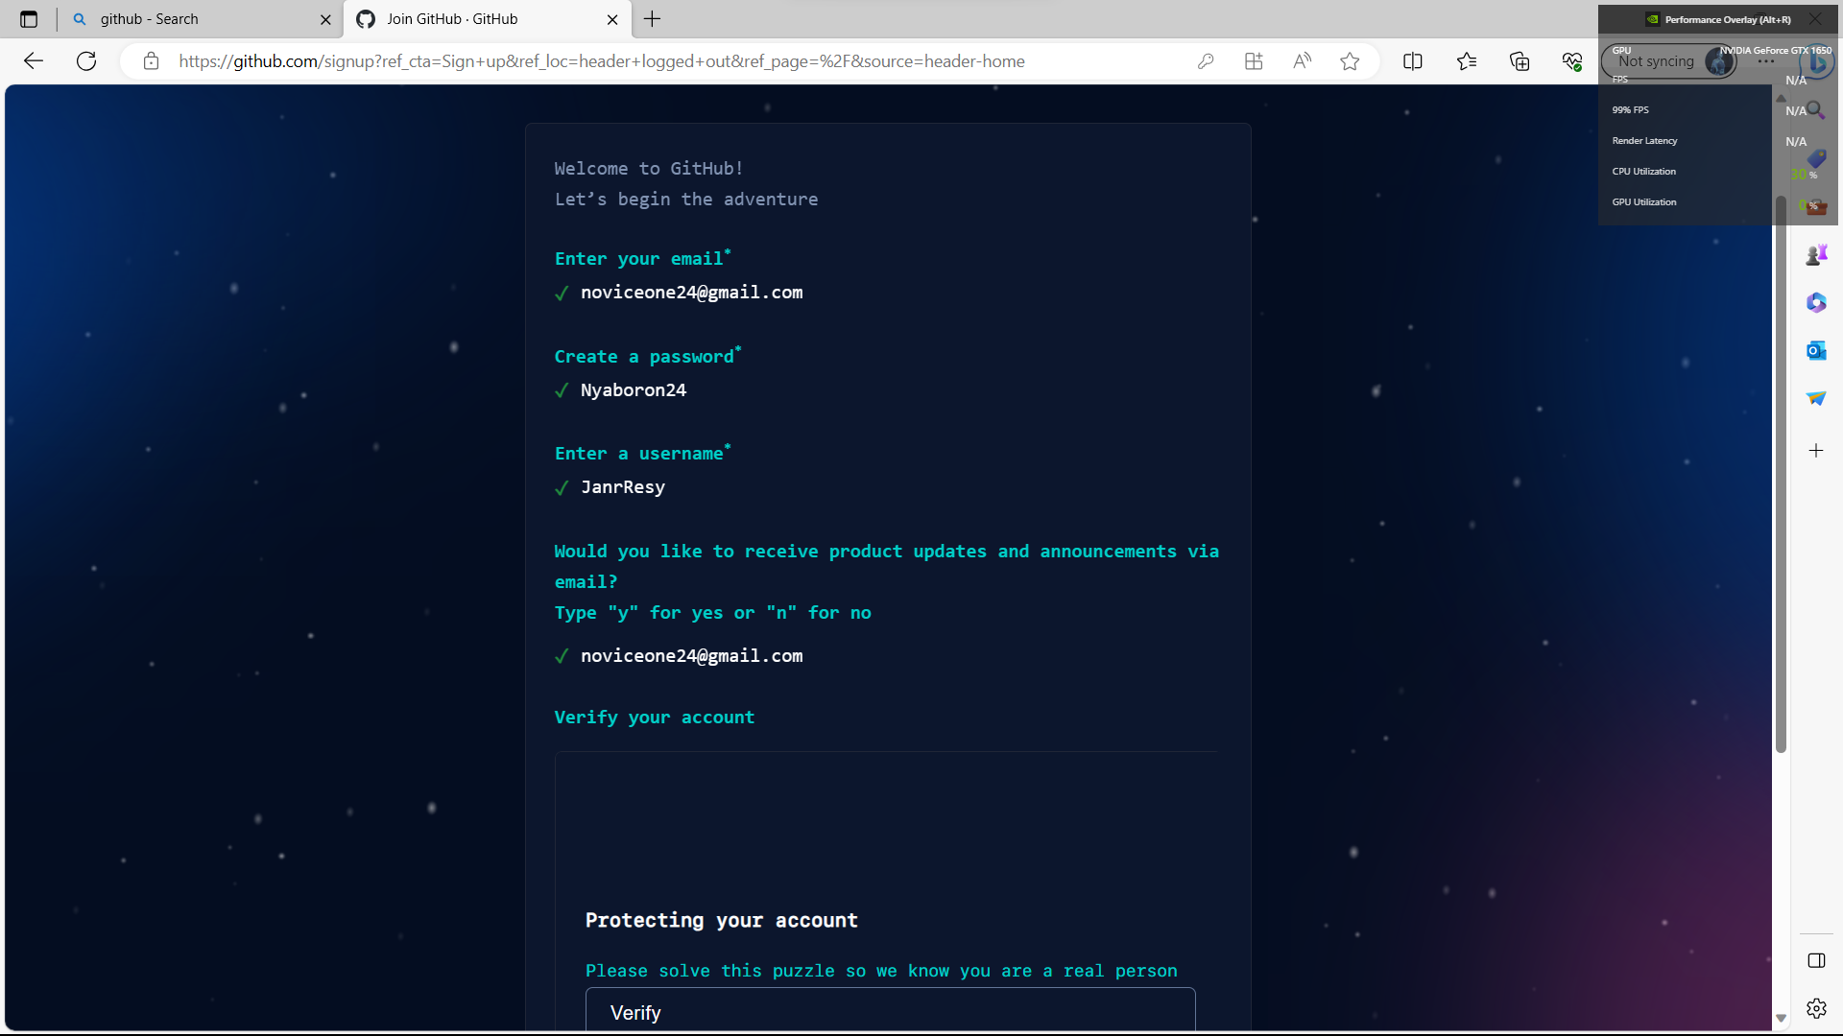

3.